MY PRACTICE SHEET
JUNIOR KG
MATH WORKSHEET
NAME: DATE: 04.09.2023
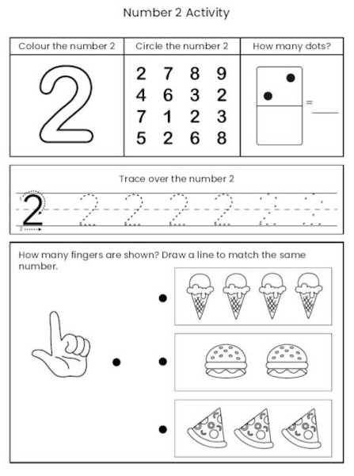

TR. SIGN REMARKS

